COMSATS UNIVERSITY ISLAMABAD, LAHORE CAMPUS



Name: Abdul Wahab

Registration No: FA22-BSE-160

Class: Object Oriented Programming

Assignment: Lab Task 8

Teacher: Mam Mamoona Tassaduq

Date: 2nd May 2023

**Task 1:** Make a class Faculty that is inherited by 2 classes PermanentFaculty and VisitingFaculty.

Class Faculty has two attributes id and name, fully parametrized constructor and

calculateSalary() method.

Class PermanentFaculty has one attribute salary, fully parametrized constructor and overrides calculateSalary() method.

Class VisitingFaculty() has two attributes hours,salaryPerHr, fully parametrized constructor and overrides calculateSalary() method.

In PermanantFaculty class, calculateSalry method returns basic salary. In VisitingFaculty class, calculateSalry method returns hours*salaryPerHr.

In Test class create an array of Faculty (n elements) and ask user which object data to enter, 1 for PermanentFaculty, 2 for Visiting. Input data for appropriate object and save in the array.

After n objects are saved, show salary of all objects through polymorphic processing.

Now update salary of permanantFaculty by 10%. (HINT: You will have to first check for required Faculty using the instanceof operator, then, you will have to downcast to set appropriate value of the object)

**Code:**

import java.util.Scanner;  
  
//Test Class  
public class Lab8_Task1 {  
  
 public static void main(String[] args) {  
  
 Scanner scn = new Scanner(System.*in*);  
  
 System.*out*.println("Enter The Number of Faculty Members : ");  
 int n = scn.nextInt();  
 //Creating Faculty Array Here  
 Faculty[] faculties= new Faculty[n];  
  
 for(int i=0;i<n;i++){  
  
 //Asking User for Choice  
 System.*out*.println("Enter Your Choice:" +  
 "\n1: Permanent Faculty" +  
 "\n2: Visiting Faculty");  
 int choice = scn.nextInt();  
  
 scn.nextLine();  
  
 //Depends on User Choice  
 if(choice==1) {  
 System.*out*.println("Enter Employee ID:");  
 String ID = scn.nextLine();  
 System.*out*.println("Enter Employee Name:");  
 String Name = scn.nextLine();  
 System.*out*.println("Enter Employee Salary:");  
 int Salary = scn.nextInt();  
  
 faculties[i] = new PermanentFaculty(ID,Name,Salary);  
  
 } else if(choice==2){  
  
 System.*out*.println("Enter Employee ID:");  
 String ID = scn.nextLine();  
 System.*out*.println("Enter Employee Name:");  
 String Name = scn.nextLine();  
 System.*out*.println("Enter Employee Hours:");  
 int hours = scn.nextInt();  
 System.*out*.println("Enter Salary Per Hour:");  
 int SperHour = scn.nextInt();  
  
 faculties[i]= new VisitingFaculty(ID,Name,hours,SperHour);  
  
  
 }  
  
 }  
  
 //Downcasting Here to Print the Salary  
 for(int i=0;i<n;i++){  
  
 if(faculties[i] instanceof PermanentFaculty){  
  
 System.*out*.println("Salary of Permanent Faculty : "+ ((PermanentFaculty)faculties[i]).calculateSalary());  
  
 //Storing Salary here and Adding 10%  
 double SALARY = ((PermanentFaculty)faculties[i]).calculateSalary();  
  
 SALARY *= 1.1 ;  
  
 System.*out*.println("Updated Salary After 10% is : "+SALARY);  
 }  
 if (faculties[i] instanceof VisitingFaculty) {  
 System.*out*.println("Salary of Visitng Faculty : "+ ((VisitingFaculty)faculties[i]).calculateSalary());  
  
 }  
  
 }  
  
 }  
  
}  
class Faculty{  
  
 String id;  
 String Name;  
  
 public Faculty(String id, String name) {  
 this.id = id;  
 Name = name;  
 }  
  
  
 public double calculateSalary(){  
 return 0.0;  
 }  
  
}  
class PermanentFaculty extends Faculty {  
  
 int Salary;  
  
 public PermanentFaculty(String id, String name, int salary) {  
 super(id, name);  
 Salary = salary;  
 }  
  
 @Override  
 public double calculateSalary() {  
 return Salary;  
 }  
}  
  
  
class VisitingFaculty extends Faculty{  
  
 int hours;  
 int SalaryPhour;  
  
 public VisitingFaculty(String id, String name, int hours, int salaryPhour) {  
 super(id, name);  
 this.hours = hours;  
 SalaryPhour = salaryPhour;  
 }  
 @Override  
 public double calculateSalary() {  
 return hours*SalaryPhour;  
 }  
  
  
}

**OUTPUT:**

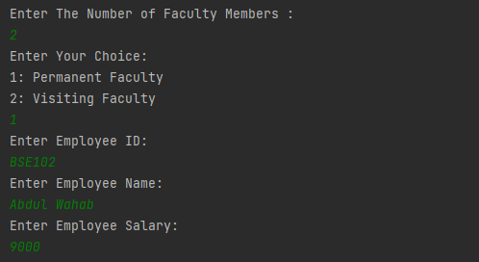

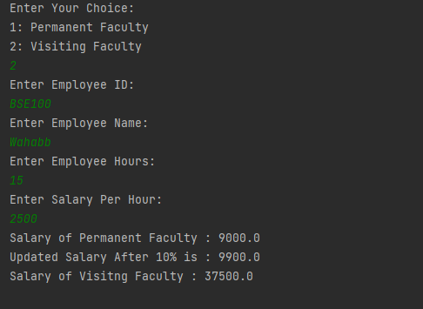

**Task 2:**

**CODE:**

import java.util.ArrayList;  
import java.util.Scanner;  
  
public class Lab8_Task2 {  
 public static void main(String[] args) {  
 Scanner scn = new Scanner(System.*in*);  
  
 System.*out*.println("Enter Number of Person:");  
 int n = scn.nextInt();  
  
 ArrayList<Person> person = new ArrayList<Person>(n);  
  
 for (int i=0;i<n;i++){  
  
 System.*out*.println("Enter Choice:" +  
 "\n1: Staff :" +  
 "\n2: Student :");  
 int choice = scn.nextInt();  
  
 scn.nextLine();  
 if (choice==1){  
 System.*out*.println("Enter Employee Name:");  
 String Name = scn.nextLine();  
  
 System.*out*.println("Enter Employee Address:");  
 String add = scn.nextLine();  
  
 System.*out*.println("Enter University Name:");  
 String school = scn.nextLine();  
  
 System.*out*.println("Enter Employee Salary:");  
 double pay = scn.nextDouble();  
  
 person.add(new Staff(Name,add,school,pay));  
  
 scn.nextLine();  
 }if(choice==2){  
  
 System.*out*.println("Enter Student Name:");  
 String sName = scn.nextLine();  
  
 System.*out*.println("Student Address:");  
 String SAdd = scn.nextLine();  
  
 System.*out*.println("Enter Student Program:");  
 String prog = scn.nextLine();  
  
 System.*out*.println("Enter Year:");  
 int year = scn.nextInt();  
  
 System.*out*.println("Enter Fees:");  
 double fees = scn.nextDouble();  
  
 person.add(new Student(sName,SAdd,prog,year,fees));  
  
 }  
  
 }  
  
 for (Person person1 : person){  
  
 System.*out*.println(person1);  
  
 }  
  
 }  
  
  
}  
  
class Person{  
  
 private String Name;  
 private String Address;  
  
 public Person(String name, String address) {  
 Name = name;  
 Address = address;  
 }  
  
 public String getName() {  
 return Name;  
 }  
  
 public void setName(String name) {  
 Name = name;  
 }  
  
 public String getAddress() {  
 return Address;  
 }  
  
 public void setAddress(String address) {  
 Address = address;  
 }  
  
 @Override  
 public String toString() {  
 return "Person{" +  
 "Name='" + Name + '\'' +  
 ", Address='" + Address + '\'' +  
 '}';  
 }  
}  
  
class Student extends Person{  
  
 private String Program;  
 private int Year;  
 private double fees;  
  
 public String getProgram() {  
 return Program;  
 }  
  
 public void setProgram(String program) {  
 Program = program;  
 }  
  
 public int getYear() {  
 return Year;  
 }  
  
 public void setYear(int year) {  
 Year = year;  
 }  
  
 public double getFees() {  
 return fees;  
 }  
  
 public void setFees(double fees) {  
 this.fees = fees;  
 }  
  
 public Student(String name, String address, String program, int year, double fees) {  
 super(name, address);  
 Program = program;  
 Year = year;  
 this.fees = fees;  
 }  
  
 //TOString Here  
  
  
 @Override  
 public String toString() {  
 return "Student{"+super.toString() +"Program='" + Program + '\'' +", Year=" + Year +  
 ", fees=" + fees +  
 '}';  
 }  
}  
class Staff extends Person{  
  
 private String School;  
 private double Pay;  
  
 public Staff(String name, String address, String school, double pay) {  
 super(name, address);  
 School = school;  
 Pay = pay;  
 }  
  
 public String getSchool() {  
 return School;  
 }  
  
 public void setSchool(String school) {  
 School = school;  
 }  
  
 public double getPay() {  
 return Pay;  
 }  
  
 public void setPay(double pay) {  
 Pay = pay;  
 }  
  
 //ToString Here  
  
  
 @Override  
 public String toString() {  
 return "Staff{"+super.toString() +  
 "School='" + School + '\'' +  
 ", Pay=" + Pay +  
 '}';  
 }  
}

**OUTPUT:**

